## PROVIDER DIRECTORY

The Provider Directory allows you to search for providers within your own HIE and, in some cases, other exchanges.

### Searching the Provider Directory

Multiple options exist for searching the Provider Directory, each found in the *Criteria* drop-down box of the Provider Directory search page:

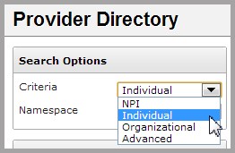

* The **NPI** (National Provider Identifier) option requires a 10-digit number from the [NPI Registry](https://npiregistry.cms.hhs.gov/NPPESRegistry/NPIRegistryHome.do) available from CMS.
* Selecting **Individual** searches for a clinician by name or location.
* Selecting **Organizational** searches for a hospital, clinic, or other organization by name or location.
* Selecting **Advanced** provides a number of additional search options, and allows search by **Individual** or **Organization** provider types.

To make a search more specific, you may choose **Combined**, **Local**, or **Global** fromthe*Namespace* drop-down. In most cases, you will use the combined namespace filter. The global namespace will search the Provider Directory for entries from the NPI Registry. The local namespace searches for manual entries to your HIE’s Provider Directory.

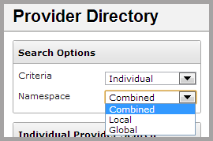

### Viewing a Provider

Once a provider is selected, the *Provider Detail* screen appears, showing the **View Provider** tab.

On this screen, information about the provider is divided into four sections:

* *Basic Provider Information*: includes basic demographics, contact information, and NPI information.

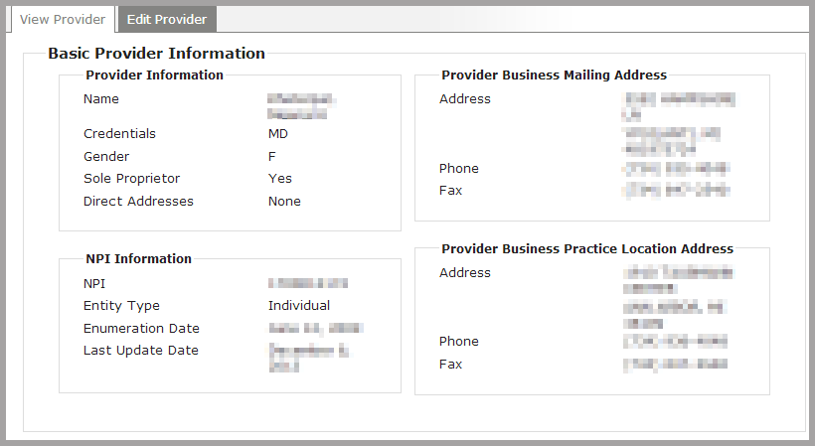

* *Provider Licenses*: includes information about specific medical licenses that the provider has been granted, the associated taxonomy code for each license.

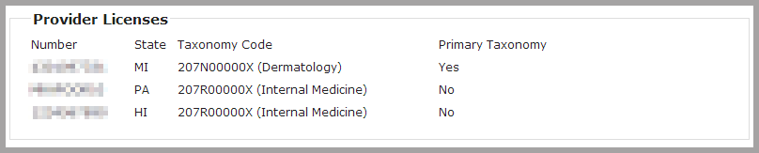

* *Other Provider Identifiers:* lists other sources of licenses or credentials.

Note: this section will not appear if other provider identifiers have not been added.



* *Data Sources*: specifies the primary source of the information displayed on the **View Provider** tab.

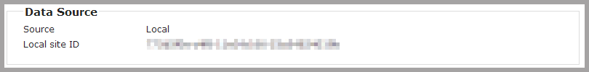

* *Other Sources*: lists any additional sources of information available for this provider.



Note: other data sources can be viewed as the primary data source on the **View Provider** tab. To do so, click **expand** on theProvider Directory search results, and then choose a listed data source.

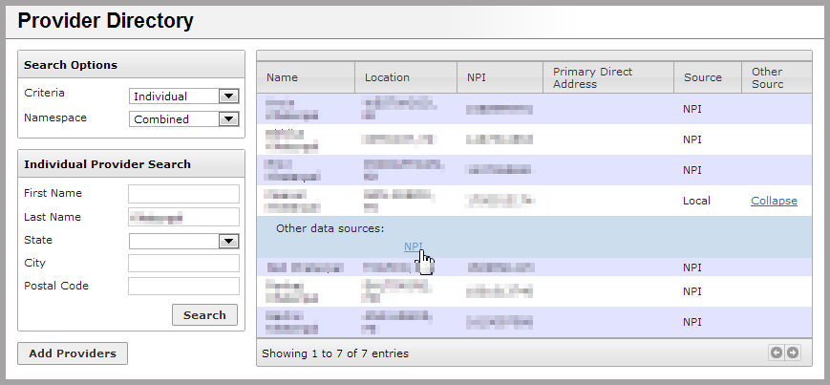

### Adding a Provider

To add a provider to the local Provider Directory, click the **Add Providers** button at the bottom of the *Provider Directory* search page. After clicking, enter a valid 10-digit NPI number in the appropriate box.

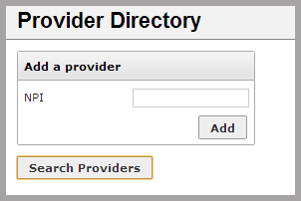

If the NPI number is already being used in the local directory, the message “NPI is already assigned” will appear. If the NPI number is not 10 digits long, the message “NPI must be a 10 digit number” will appear.

If the NPI number entered is 10 digits long and is not already being used the local directory, a new provider entry will be created. Search for the new NPI number to begin editing that provider’s information.

### Editing a Provider

On the **Edit Provider** tab of the *Provider Detail* screen, provider information can be changed or deleted. Changes made will be added to the local Provider Directory.

Note: changing any information for a provider will change the *Data Source* listed on the **View Provider** tab to “Local”. Any other sources of information (including NPI) will then be listed in the *Other Sources* section.

Information displayed is divided into three sections. Edits to each of these sections can be made as follows:

* *Basic Provider Information:* to change information, type in the appropriate text box or select an option from a drop-down. The NPI number cannot be changed, however the NPI entity type can be set to **Individual** or **Organization**. When finished, click on the **Save Changes** button.

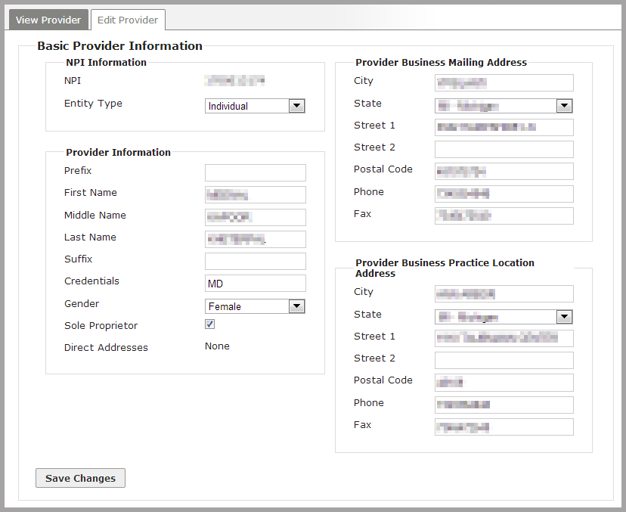

* *Provider Licenses:* to delete any listed license from the local Provider Directory, click the **Delete** buttonnext to the appropriate license listing. To add a license, click the **Add a License** button.

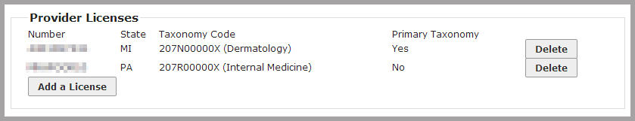

* *Other Provider Identifiers:* to delete any listed identifier from the local Provider Directory, click the **Delete** buttonnext to the appropriate identifier listing. To add an identifier, click the **Add an Identifier** button.



### Deleting a Provider

To delete a provider from the local Provider Directory, search for that provider and navigate to the **Edit Provider** tab, and click on the **Delete** buttonat thebottom of the screen. A warning window will appear:

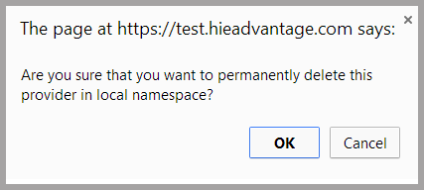

Click **OK** to delete the provider from the local namespace, and **Cancel** to keep the provider.